**CSE 465/565**

**Spring 2023**

**Homework #1**

**50 points**

*Instructions: Submit to Canvas a single PDF file. For each exercise, you will see the points in parenthesis.*

**1. (10 p)** Log into ceclnx01.cec.miamioh.edu and create a new folder for this class. Copy the file test.py provided to you into this new folder. On the ceclnx01 server, run the following command:

python3 test.py

Type the command exactly as you see it above. Take a snapshot of the commands’ output and insert it into your PDF.

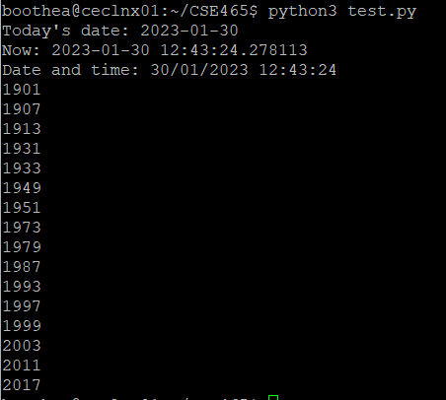

Note: You are not required to understand the code in test.py. This exercise simply allows me to check that you can successfully use the ceclnx01 server.

**2. (20 p).** Fill the table below with one advantage and one disadvantage for compilation and pure interpretation.

|  |  |  |
| --- | --- | --- |
| ***Implementation Method*** | ***Advantage*** | ***Disadvantage*** |
| Compilation | Fast execution, translation makes resulting program faster | Good compilers are difficult to write |
| Pure Interpretation | Runtime errors are immediately displayed | 10-100 times slower execution than compiler |

**3. (10 p)** In 2-3 sentences, describe the **JIT (Just-in-Time)** language implementation method.

**Just-in-time implementation is the process of a code being compiled translated into an intermediary language like machine code before being executed. Just-in-time combines the dynamic error output of interpretation and efficiency of compilation. The resulting increased speed poses both benefits and restrictions as opposed to pure compilation or interpretation.**

**4. (10 p)** What is the most common or prototypical language for the following **application domains** (according to the textbook)?

Business: **COBOL**

Scientific programming: **Fortan**

Systems programming: **C**